Bociat Daniel-Tiberiu

1. Create a database containing at least three tables so that the tables have relations with each other. The tables must contain both primary and foreign keys

**2)** Using the Forward Engineer-function, move the tables to a MySQL server. Server can be localhost or some network server.

As a result, show an image of the ER diagram and the last step of the Forward Engineer-command.

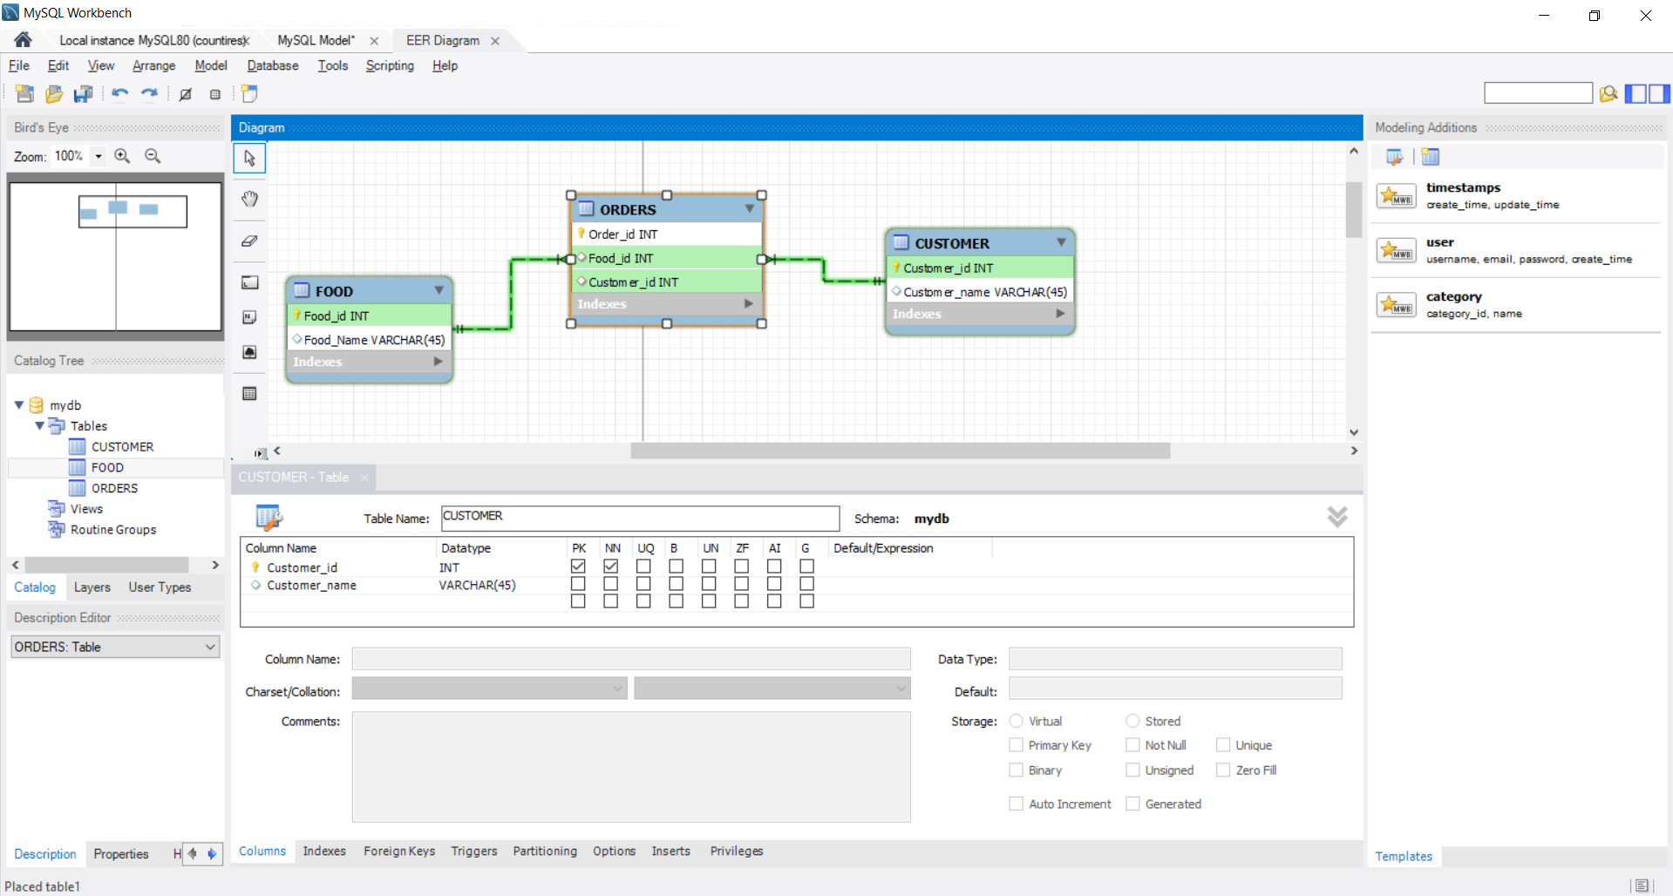

-- MySQL Workbench Forward Engineering

SET @OLD_UNIQUE_CHECKS=@@UNIQUE_CHECKS, UNIQUE_CHECKS=0;

SET @OLD_FOREIGN_KEY_CHECKS=@@FOREIGN_KEY_CHECKS, FOREIGN_KEY_CHECKS=0;

SET @OLD_SQL_MODE=@@SQL_MODE, SQL_MODE='ONLY_FULL_GROUP_BY,STRICT_TRANS_TABLES,NO_ZERO_IN_DATE,NO_ZERO_DATE,ERROR_FOR_DIVISION_BY_ZERO,NO_ENGINE_SUBSTITUTION';

-- -----------------------------------------------------

-- Schema mydb

-- -----------------------------------------------------

-- -----------------------------------------------------

-- Schema mydb

-- -----------------------------------------------------

CREATE SCHEMA IF NOT EXISTS `mydb` DEFAULT CHARACTER SET utf8 ;

USE `mydb` ;

-- -----------------------------------------------------

-- Table `mydb`.`FOOD`

-- -----------------------------------------------------

CREATE TABLE IF NOT EXISTS `mydb`.`FOOD` (

`Food_id` INT NOT NULL,

`Food_Name` VARCHAR(45) NULL,

PRIMARY KEY (`Food_id`))

ENGINE = InnoDB;

-- -----------------------------------------------------

-- Table `mydb`.`CUSTOMER`

-- -----------------------------------------------------

CREATE TABLE IF NOT EXISTS `mydb`.`CUSTOMER` (

`Customer_id` INT NOT NULL,

`Customer_name` VARCHAR(45) NULL,

PRIMARY KEY (`Customer_id`))

ENGINE = InnoDB;

-- -----------------------------------------------------

-- Table `mydb`.`ORDERS`

-- -----------------------------------------------------

CREATE TABLE IF NOT EXISTS `mydb`.`ORDERS` (

`Order_id` INT NOT NULL,

`Food_id` INT NULL,

`Customer_id` INT NULL,

PRIMARY KEY (`Order_id`),

INDEX `Food_id_idx` (`Food_id` ASC) VISIBLE,

INDEX `Cumsotmer_id_idx` (`Customer_id` ASC) VISIBLE,

CONSTRAINT `Food_id`

FOREIGN KEY (`Food_id`)

REFERENCES `mydb`.`FOOD` (`Food_id`)

ON DELETE NO ACTION

ON UPDATE NO ACTION,

CONSTRAINT `Cumsotmer_id`

FOREIGN KEY (`Customer_id`)

REFERENCES `mydb`.`CUSTOMER` (`Customer_id`)

ON DELETE NO ACTION

ON UPDATE NO ACTION)

ENGINE = InnoDB;

SET SQL_MODE=@OLD_SQL_MODE;

SET FOREIGN_KEY_CHECKS=@OLD_FOREIGN_KEY_CHECKS;

SET UNIQUE_CHECKS=@OLD_UNIQUE_CHECKS;

